Houston, We Have a Problem: Cost of Risk to Traffickers, Buyers and Victims in the Commercial Sex Trade
In May 2021 the authors of the article, Houston, We Have a Problem: Cost of Risk to Traffickers, Buyers and Victims in the Commercial Sex Trade, estimated the cost of risk to traffickers and buyers to victims in the commercial sex trade within Houston, Texas. Researchers sough to estimate the cost of risk in order to help policy makers, law enforcement, prosecutors, and others approach the commercial sex industry more efficiently. By raising the risk for exploiters and reducing harm to victims, researchers believe this will help end the demand for commercial sex and put sex traffickers out of businesses.

As sex trafficking and commercial sex are illegal enterprises, accounting of the cost of risk should any involved party be arrested, convicted, and fined were determined as key components. In any industry, demand drives supply and profit. The commercial sex industry is no different. Researchers began with predicting the extent of sex trafficking victimization, including estimated prevalence, value, profit in Houston, Texas.

Researchers created mathematical equations for the following topics in order to create a comprehensive estimation of cost of risk:
- Estimated Value of a Sex Trafficking Victim
- Predictive Modeling: Sex Trafficking Victimization in Houston
- Total Demanded Commercial Sex Acts
- Predictive Modeling: Sex Traffickers in Houston
- Predictive Modeling: Commercial Sex Buyers in Houston
- Total Victim Arrests

Researchers used the following data to create estimation equations in order to accurately estimate the cost of risk in Houston, Texas:
- On average, commercial sexual exploitation (CSE) victims are forced to earn roughly $1000 (gross) per day for their traffickers in Houston, Texas.
- On average, sex traffickers have about a 70% profit margin per victim based on the following overhead costs: hotel, food, advertising, condoms, grooming/clothing.
- In Houston in 2019, a total number of 214,181 advertisements were posted online for commercial sex.
- A total of 18,639 individual profiles existed across commercial sex advertising platforms in the Houston area.
- Victims are held to an average of $1000/day quota, which can be earned in anywhere from 1–10 commercial sex acts, 5 being the average.
- The average sex trafficker has between 4–8 victims.
- Human trafficking in Texas is a felony of the second degree and although the law permits a maximum fine of $10,000, this is likely not the average fine.
- The maximum federal fine for human trafficking is $1.5 million.
- The maximum fine for a Class A Misdemeanor charge for buying sex is $4,000 if they have previous prostitution convictions in Texas.
- The maximum fine for a Class A Misdemeanor charge for soliciting prostitution of another person is $4,000 in Texas.
- The total adult male population in the Houston metropolitan area as a starting point, N= 2,649,802.
- Research shows that on average, 6% of Houstonian males purchase sex in a 12-month period.
- In Houston, 203 men were arrested on charges of prostitution in 2019 and 175 were convicted.
- In Houston, 644 women were arrested with a prostitution charge in 2019.
- Relative to the total predicted number of victims (14,539), this a relatively low arrest rate (4%) of sex trafficking victims in Texas.
- Law enforcement have shifted away from arresting prostituted persons in Harris County. Project 180 (P-180), a prostitution diversion program was instituted by the Harris County District Attorney’s Office in 2017.
- On average, 174 individuals are diverted to P-180 each year.

In Houston, Texas, researchers estimated that:
- Victims are valued at roughly $182,000 per year.
- There are roughly 14,539 total victims in the greater Houston area in 2019.
- an average of 3,635 traffickers exploiting victims each year.
- Victims are demanded to perform an estimated 18,900,700 commercial sex acts per year.
- The minimal annual cost a trafficker needs to plan for should he get arrested, convicted, and fined the maximum amount allowed in the state of Texas is $66.85 per year ($.01 per month).
- To account for the risk of arrest, buyers in Houston, Texas only need to save $.04 per commercial sex act purchase.
- The minimal annual cost a buyer needs to plan for should he get arrested, convicted, and fined the maximum amount allowed in the state of Texas is $.44 per year ($.04 per month).
- There are roughly 158,988 sex buyers in Houston
- The cost of risk for sex traffickers and buyers is $5.19 per commercial sex act

The Table below presents a side-by-side comparison of buyers, traffickers, and victims for engaging in the commercial sex trade. It should be noted here that actual choice to engage in the commercial sex trade lies only in the hands of buyers and traffickers, yet their cost of risk is negligible. In fact, victims’ cost of financial risk is over 100 times that of a trafficker. The majority of research on sex trafficking victimization reveals that victims do not earn any of the money that is exchanged for sex.
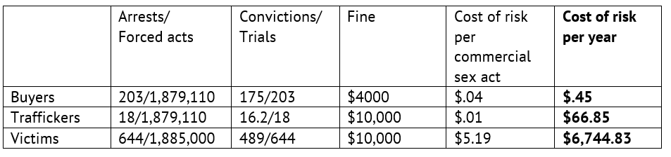
Table 1. Cost of Risk to Traffickers, Sex Buyers and Prostituted People/Victims in Houston, Texas (2019)

