San Jose Police Announce 'Report John Program' To Combat Prostitution, Human Trafficking
SEPTEMBER 8, 2019 / 6:06 PM / CBS SAN FRANCISCO
https://www.cbsnews.com/sanfrancisco/news/san-jose-police-announce-report-john-program-to-combat-prostitution-human-trafficking/
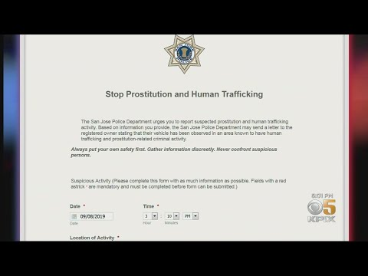
SAN JOSE (KPIX 5) -- Touted as yet another tool in their arsenal to combat human trafficking and prostitution in San Jose, police announced this week a new online portal for residents to report the crime that's known to plague areas of the city.
In what's been dubbed as "The Report John Program," residents are able to remain anonymous and report someone they believe has picked up a prostitute. The online form includes where the suspicious activity took place, the description of the car and driver, as well as an option to upload a picture.
Edson Mendoza, who grew up in San Jose, said Monterey Highway is known as the street where prostitutes come out at night.
"It's really known for it," said Mendoza. "Just like a lot of prostitutes, girls just walking around, waiting to get picked up...you see a lot of cars stopping by."
But San Jose police's new tool isn't without any debate or controversy.
If warranted, police said further investigation would be done and if appropriate, the department would send "public safety announcement" letters to the car's registered owner, and alert them that they've been spotted in an area known for high levels of prostitution.
San Jose police isn't the first agency to send "Dear John" letters. A couple years ago, when Oakland police launched a similar program, human rights advocates actually pushed back and argued it would do more harm than good. For example, they said it would push women to interact with clients they weren't familiar with.
"They're just trying to feed their families, pay their bills," said "Elizabeth," who wanted to remain anonymous. She lives near Monterey Highway and said she has friends who are prostitutes in the area.
"I don't really think it's going to help because this profession has been going on for so long," she said "They haven't stopped it yet, it's probably not going to stop anytime soon."
Police said they hope the letters serve to educate people who receive them about the dangers of prostitution and the activities associated with it, but others have argued it's a violation of privacy — especially if the person is innocent.
"You know, I could see if you were standing in front of somebody's house and your kids are playing, OK, that's wrong, but if you're just minding your own business, kind of tucked away, it shouldn't be a problem," Elizabeth said.
Mendoza said it would just be nice to see a change in Monterey Highway's reputation.
"It'd be nice for it to be known for something else," he said.
A spokesperson with Community Solutions, a human trafficking victim advocacy group, said SJPD is the first agency in the South Bay to use an anonymous online form for this purpose, and they're hoping other cities in the area adopt the form as well.

