Solicitation of Prostitution Via Text – 4 Things To Know Now If You’re Arrested
Heiu Vu
https://vulawoffice.com/prostitution/solicitation-of-prostitution-via-text/

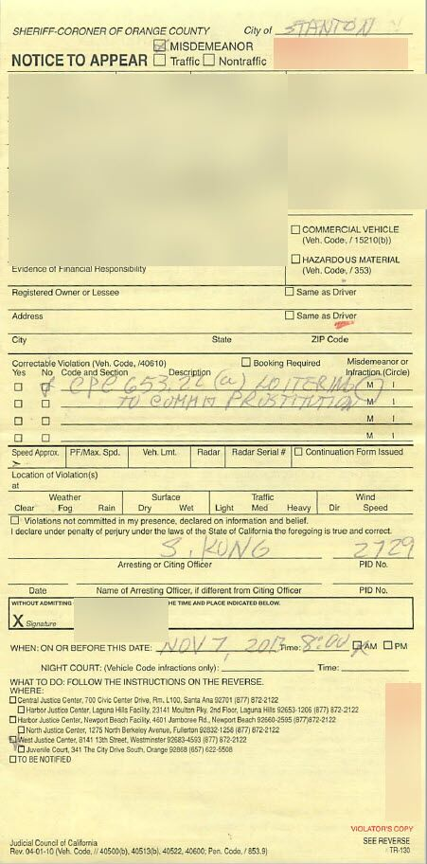
In Orange County, California, if you are arrested in a sex sting, you are looking at potential penalties of jail time, fines, and being placed on the Orange County District Attorney’s List of Sex Purchasers. In addition, you are risking your significant other discovering what happened and your marriage being at stake.

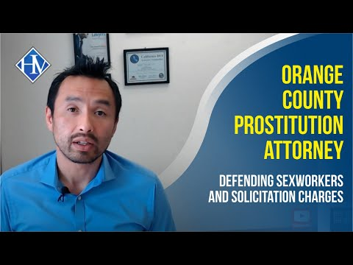
It is possible to be convicted of a prostitution charge based on the contents of your cell phone (Solicitation of Prostitution Via Text)
However, it is not an easy crime for the prosecution to prove. Texting with someone doesn’t necessarily fulfill the requirements for solicitation. There are several things they need to show, such as you were using the internet to solicit individuals for sex.

This article will go over what the prosecutors need to prove to make a prostitution case under the Solicitation of Prostitution Via Text theory, the difficulties they run into, and what you should do if you face a prostitution charge. It’s important to remember that the strongest evidence against you is a cell phone, and it is important to remain silent.

- Do not give the passcode to your cellphone if you are accused of prostitution through a Solicitation via Text theory.

This item makes the list because once you give the police access to your cell phone, then they can see all your text messages. This includes text messages and the browsing history of the site you used ie Bedpage, Rubmaps, Humuniplex. If you do not do this, you put everything on the state to prove the case against you, making the case more difficult to prove.

The police need to establish that you sent the text messages. This makes the case an identity issue of who sent the text messages. It is much harder to prove a solicitation charge just for showing up or being around a providers’ place of business (house of prostitution) after a phone call. The police will need to establish that you were with the intent to engage in sexual services with an agreement of money for sex beyond a reasonable doubt.

If there were text messages exchanged, the police would need access to them. The prosecutors will need to prove that you are the owner of the phone and the text messages came from you, and you were not spoofed by someone else. Sometimes, they may take your cell phone and text it on their own to see if the notifications pop up if they don’t have a passcode.

- When accused of Solicitation of Prostitution Via Text Exercise your right to remain silence

The police will need to show the agreement. You can’t be convicted for using the internet to solicit individuals for sex if there is no agreement for sexual services. Texting with someone is not illegal even if they are providers who usually engage in money for sex. Briefly, there are other alternatives and explanations for you to contact a person in the sex industry. (dating, relative, friend, etc.)

Arrested Does not Mean you are Convicted.

Even if they proved that the phone belongs to you, then they still must show agreement. If you were smart enough not to agree on a price, you need to know enough to exercise your right to remain silent. Solicitation of prostitution can only happen when there is an agreement for an exchange for money. This is a consumer problem as opposed to a provider issue.
If you are providing services, you are likely experienced and know what to do when confronted by the police. Exercising your right to remain silent will let a criminal defense attorney use one of the common defenses for your case.

If you are accused of being a sex purchaser, you should not say anything that will implicate you and suggest that you pay for sex. The last thing you need is to feel hopeless and look for forgiveness from the police officer and to tell the police that the $275.00 in your back pocket was there for you to buy sex.

You need to know your right to remain silent, not talk, and let your criminal defense attorney develop an effective defense for you. There is no need to give the state additional evidence to make a case against you

- Once you are released and given a ticket for Solicitation of Prostitution Via Text, contact a Lawyer.

If you are accused of being the purchaser, then you will be given a ticket with a court date. A lawyer can figure out where the hole is in the prosecution’s case. The lack of evidence on these types of cases results from several factors. Some of these will include the lack of sexual conduct and insufficient evidence to prove an agreement of sex in exchange for money. The next few paragraphs will go into these in more detail.

You can be arrested for Solicitation of Prostitution Via Text without showing up in person.

The first one is called the human trafficking angle. The police wanted to get the main provider pimp, and you were only caught up in it and were only part of the investigation. (For example, you were parked in front of a condo and went into the house for 15 minutes) These cases occur when you work for the government and have protected plates on your car (police officer, judges, prosecutors)

If you are a sex worker, then an attorney who is local and familiar with the courthouse will be able to get you into a program. An educational program can be able to dismiss the charges for you, thus avoiding a criminal record.

If you are a provider, then the chances are high that you invoked your right to lawyer up. Besides this, laws passed in 2020 exclude condoms from all prosecution cases against you. This means you could have had several condoms around the ara, and none of it can be seen by the jury who will be deciding on your case.

Assuming you were the girl working and foresee yourself moving out of state soon. If so, you will need an attorney to represent you in court so you can leave the state and not have a warrant under your name for engaging in sexual conduct for money.

But even if there is no agreement, the government can move forward with the totality of the circumstance theory that you were there for sexual intercourse and other sexual activity—if you came with condoms.

- Watch your mailbox if you do not want your Significant other to discover you being arrested for Prostitution.

If you do not want your significant other to find out about your sexual conduct, you need to watch your mailbox. You will get advertisements from attorneys who will solicit you for your arrest of Prostitution charges. If you live in Orange County, you can expect these to hit your mailbox within the week of arrest and last for about a week.
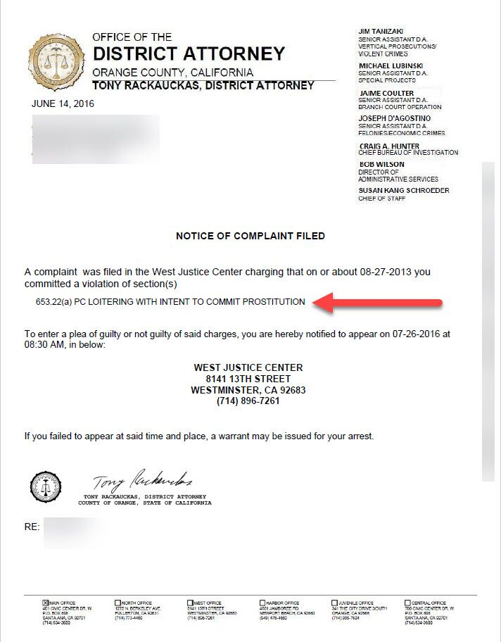Solicitation of Prostitution Via Text is a way for law enforcement to make a case against you when all their facts are not there.

If you were accused of a sexual solicitation crime and the theory was one of Solicitation of Prostitution Via Text, then it’s important that you know the options available to you based on your facts. The penalties for solicitation can be avoided. The crime of solicitation is hard to prove for law enforcement if they have no admission and only text messages. They need to prove sex for money, and there was no observed sexual conduct. A criminal defense lawyer may work on lagging out a case that makes for insufficient evidence or obtain an officer’s body cam to shed light on a situation different from a police report and show another side of the story.

