Case involved prostitutes as young as 14
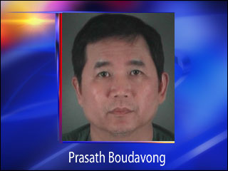
Story Published: Jun 11, 2009 at 5:23 PM PDT

By Elissa Harrington KVAL News
EUGENE, Ore. -- Prostitutes as young as 14 were hired by the former owner of a Springfield restaurant, who pleaded guilty to rape and sodomy charges Wednesday.
Prasath Boudavong, 56, pleaded guilty Wednesday to sodomy and rape of prostitute girls as young as 14. He was sentenced to 240 days in jail under a plea agreement. He could have faced 6 years in prison if found guilty by a jury.
Boudavong is the former owner of Far Man restaurant on Gateway Boulevard.
"There were 4 victims in his case," said Detective Curtis Newell with the Eugene Police Deparment. "However, we believe he has probably been with several others."
Pimps, prostitutes and johns
Police say Boudavong had been using a pimp for the past two years. Boudavong would bring the prostitutes to a Springfield home he owned to have sex.
"There actually is a pretty organized prostitution ring our in the area," Newell said, "and that's kind of what we have been kind of scratching the surface on."
Newell said police have arrested a pimp and six underage prostitutes. He anticipated another 12 prostitutes over the age of 18 could be arrested as part of the ongoing investigation.
House not far from park
Marne Nelson lives on the same street as the house where Boudavong repeatedly brought prostitutes to have sex.
She goes to a park just half a block away with her grandson and great niece.
"I'm just stunned," she said. "That's pretty scary. I hope people bring their kids down here and watch them."
Boudavong had no criminal history. Those who knew him said they're shocked by these charges.
Former co-workers at Far Man chinese restaurant paint a much different picture of him.
"He was a heck of a boss," said Evelyn Gross. "I mean you couldn't ask for a better boss."
Pamela Johnson called him a "very kind giving man, family oriented."
They said he hasn't been the owner here since May. They also said he never hired any young girls or gave any indication he was engaging in illegal activity.
"I'm too shocked to even comment on why he would do something like this because he was always here," said Johnson. "I don't see how he would have time to do anything else."

