Fargo man charged in Clay County with trying to hire minor for prostitution

MOORHEAD-A Fargo man has been charged in Clay County District Court in connection with an underage sex sting. Alan Kenneth Stokke, 60, faces one count of attempting to hire someone under 18 but at least 16 years old for prostitution. According to a...
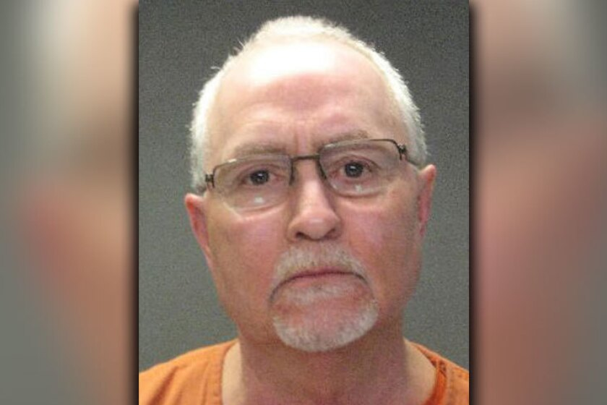
Alan Kenneth Stokke
By David Olson
March 13, 2017 04:02 PM
https://www.inforum.com/newsmd/fargo-man-charged-in-clay-county-with-trying-to-hire-minor-for-prostitution

MOORHEAD-A Fargo man has been charged in Clay County District Court in connection with an underage sex sting.
Alan Kenneth Stokke, 60, faces one count of attempting to hire someone under 18 but at least 16 years old for prostitution.
According to a court complaint:
Moorhead police were alerted by a North Dakota law enforcement agency on Friday, March 10, that as part of an undercover operation aimed at individuals targeting minors for commercial sex an individual identified in the court complaint as Stokke answered an online ad and was attempting to arrange to have sex with an officer posing as a 16-year-old.
A meeting was set up in Woodlawn Park in Moorhead and a police detective was at the park when Stokke arrived.
Stokke told the detective he was there to have sex with a female he believed to be 16, according to the complaint. The complaint said Stokke also said he brought methamphetamine with him for the meeting.
Fargo police announced on Friday that nine people-eight in Fargo and one in Grand Forks-were arrested last week in connection with an ongoing undercover operation called "Guardian Angel."
The operation was launched last summer when authorities in the Fargo-Moorhead area arrested 18 people for seeking to hire minors for commercial sex.

