Harwood man sentenced in prostitution case

MOORHEAD - A man charged with soliciting prostitutes at a hotel here in March has pleaded guilty and was sentenced Thursday in Clay County District Court.
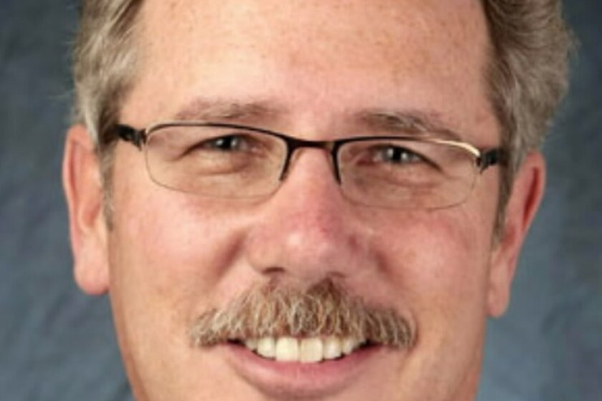
Mark Hayes
By Forum staff reports
September 11, 2014 06:46 PM
https://www.inforum.com/newsmd/harwood-man-sentenced-in-prostitution-case

MOORHEAD – A man charged with soliciting prostitutes at a hotel here in March has pleaded guilty and was sentenced Thursday in Clay County District Court.
Mark Donovan Hayes, 59, of Harwood, was sentenced to one year of unsupervised probation, a suspended 30-day jail term and a $500 fine as part of a plea agreement with prosecutor Pamela Harris.
Hayes is the information technology director at Forum Communications Co., which owns The Forum. He previously declined to comment on the matter.
Hayes and David Lawrence Skoglund, 61, of Canova, S.D., were caught at 1:17 and 6:50 p.m. on March 26, respectively, in an undercover police sting operation at a hotel in the 600 block of 30th Avenue South here.
Skoglund was a Democratic candidate for the South Dakota Legislature for District 8, but dropped out of the race in the wake of the sting operation. He pleaded guilty in August and received the same sentence as Hayes.

