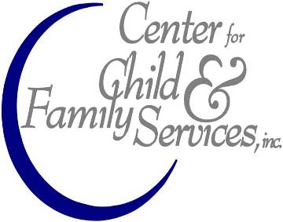2021 Cunningham Drive Suite 400
Hampton VA 23666  Ph 757-838-1960
John School
(Going from locking up suppliers to educating buyers)
John: male clients of female prostitutes
Program details:
- Group meeting time and place: Tuesdays, 5:30 – 7:00pm.
- Location: Child & Family Services, 2021 Cunningham Drive, Suite 400, Hampton, VA 23666, phone (757) 838-1960, fax (757) 838-3280.
- Total cost: $230.
- John School starts on the first Tuesday of the month, the first month of every quarter (January, April, July, October)
- John School will meet for 8 consecutive weeks, and will be a closed group format (meaning there are no new group participants admitted after the group starts, participants will start and end the group together)
- John School is a 12-hour program.
- Must attend all 8 sessions to receive the program certificate of completion.
- Participant must pay $30 for the initial clinical assessment session prior to being assigned to their assigned group.
- Participant must pay $25 for each session, payable prior to group starting.
- Attendance will be reported to CCD Case Manager.
- Must be on time for each group session. If more than 10 minutes late, will not be allowed into the group session.
- Will not be allowed into group without the $25.00 payment.
John School Program objectives:
- Ensure that participants take personal responsibility for their actions
- Educate participants about the nature of prostitution law
- Increase participant’s awareness of victims of street prostitution
- Increase participant’s awareness of the dangers of street prostitution
- Increase awareness that they may have a problem with their own sexual behavior
- Change attitudes towards prostitution
- Deter from engaging in future prostitution-related activities.
John School Curriculum: The curriculum will feature the following 8 primary content areas:

- Prostitution Law and Street Facts, focusing on the legal consequences of
subsequent offenses and addressing johns’ vulnerability to being robbed or
assaulted while involved in prostitution.

- Health Education, describing the elevated risk of HIV and STD infection
associated with prostitution, and stressing that many STDs are asymptomatic
and/or difficult to detect and have long term negative impacts on health.

- Effect of Prostitution on Prostitutes, focusing on numerous negative
consequences for women serving as prostitutes, such as vulnerability to rape and
assault, health problems, drug addiction, and various forms of exploitation.

- Dynamics of Pimping, Recruiting, and Trafficking, featuring discussions of how
pimps and traffickers recruit, control, and exploit women and girls for profit, and
the links between local street prostitution and larger systems of human trafficking.

- Effect of Prostitution on the Community, describing the drug use, violence,
health hazards, and other adverse consequences that co-occur with street
prostitution.

- Sexual Addiction, focusing on how involvement in commercial sex may be
driven by sexual addiction, and where help for this condition can be sought.

- Childhood trauma, the effects of prior abuse and neglect, and its residual effects and connections to adult psychopathological behavior.

- Bringing it all together, processing all prior session information, and putting a viable plan together to prevent future sexually deviant behaviors, and offering continued individual and/or group psychotherapy.

